Weekly Report
____________________________________________________________________________________________________________________________________________________________
CIRA
STAR/NESDIS
National Oceanic and Atmospheric Administration (NOAA)
____________________________________________________________________________________________________________________________________________________________

Submitted by: Maranda Hutson
Date of Submission: 29 August 2025
Prepared by: CIRA and STAR contributors

Products and Applications

Publications (Citation: followed by a short Summary: (Why & so what), & detailed summary):

Awards and Recognition
Media Interactions and Request

Blog Posts and Social Media

Travel, Workshops, Conferences, and Meeting Reports

Workshop on Machine Learning for Earth System Modelling: Five CIRA scientists participated in the 3rd Workshop on Machine Learning for Earth System Modelling on August 25-27, 2025. The workshop was held in Bonn, Germany, and was attended by 140 scientists in-person - about half of them from ECMWF - plus 100 virtual participants. The primary goals for the CIRA team were (1) to advertise CIRA’s expertise and products to the European community (especially ECMWF), and (2) to establish new collaborations. The event was a full success in both regards. Regarding Goal (1): John Haynes gave an oral presentation entitled “CIRA satellite data products for potential use in AIWP model training and evaluation”, which advertised CIRA products related to the OVERCAST project, including synthetic radar reflectivity (GREMLIN model), synthetic passive microwave, and work on short-term cloud forecasting. Kate Musgrave gave an oral presentation on the evaluation of AI models for weather prediction (AIWP) to predict tropical cyclones (TCs). Kathy Haynes gave a lightning talk and poster presentation on her work modeling ocean wave height using AI. Regarding Goal (2): The team established many new connections with colleagues at ECMWF and beyond and strengthened existing connections. For example, Kate Musgrave established a strong connection to an ECMWF colleague in charge of evaluating TC predictions of European AIWP models. This connection is likely to provide CIRA with early access to the European AI models, which is very beneficial for NOAA- and NSF-funded activities at CIRA related to accelerating AIWP use at NOAA for TC prediction. Kathy Haynes established herself during the Q&A sessions as a much thought-after expert on land cover modeling and carbon cycle modeling, which is likely to lead to one or more new collaborations in this area. Beyond those goals, the team also increased CIRA name recognition by helping with the organization of the workshop. For example, Imme Ebert-Uphoff served on the workshop’s 5-member scientific organizing committee and chaired an oral session and the lightning talks of a poster session. She was asked to serve again on the scientific organizing committee of the next workshop in 2026. Marshall Baldwin chaired an oral session at the workshop. Kathy Haynes and Kate Musgrave each chaired lightning talks for a poster session. (POC: I. Ebert-Uphoff, K. Haynes, K. Musgrave, M. Baldwin, J. Haynes, CIRA, iebert@colostate.edu, funding: NSF, CIRA)
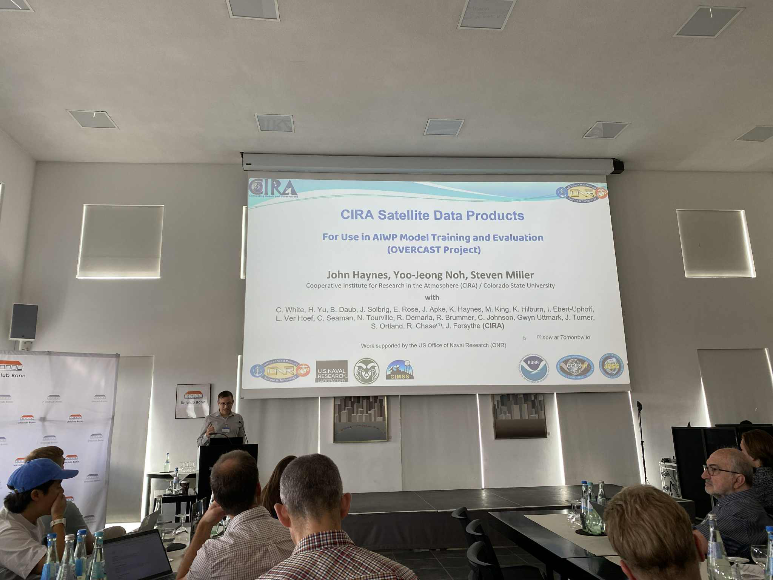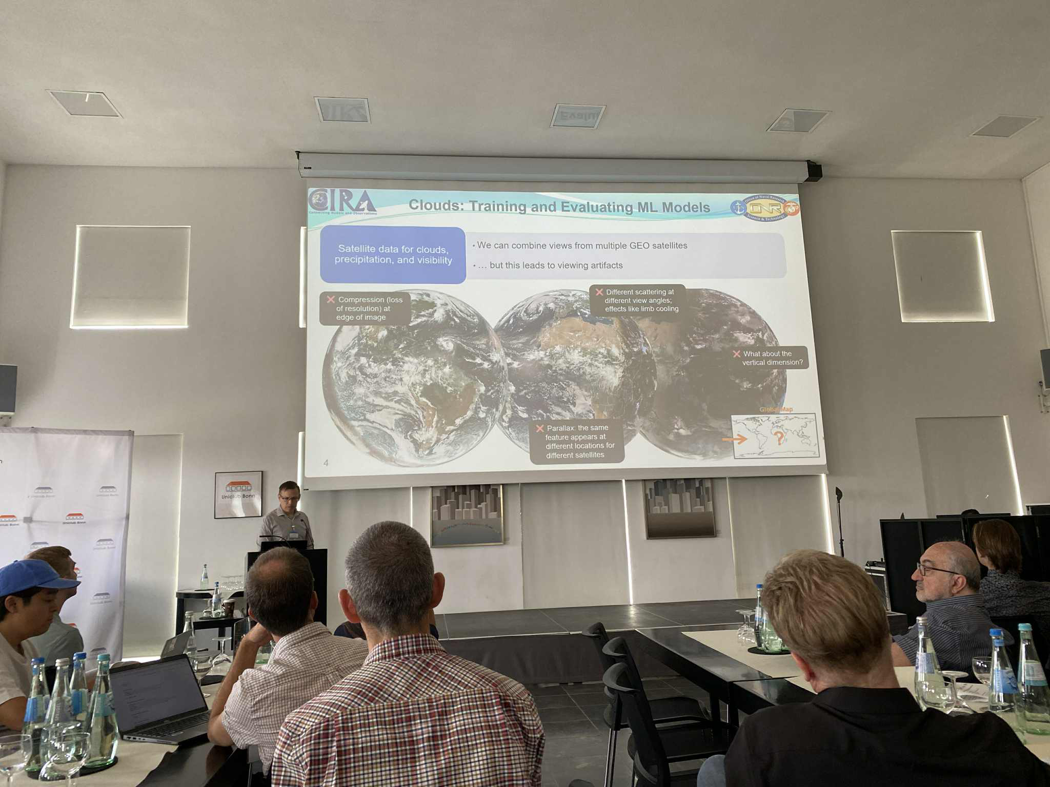
John Haynes presenting on “CIRA Satellite Data Products for use in AIWP Model Training and Evaluation” at the 3rd Workshop on Machine Learning for Earth System Modelling (Bonn, Germany; Aug 25-27, 2025).

Training and Education activities

JPSS Teletraining Session: On 26 August 2025, J. Torres (CIRA) led a VIIRS Flood Map teletraining session with NWS WFO Sterling, VA; two forecasters attended the session. (POC: Jorel Torres, CIRA, jorel.torres@colostate.edu) Funding: JPSS.

Future Meetings and Events (dates, meeting/event, location, staff involved)
Other

